DATA CLEANING, PREPROCESSING AND EXPLORATORY DATA ANALYSIS
Prepared by: Kudzai Lynn Ziso
Tools Used: Python, Pandas, Matplotlib, Jupyter Notebook

1. Introduction
This project focused on cleaning, preprocessing, and performing exploratory data analysis (EDA) on two sets of datasets.
The first analysis focused on Fake News Detection, using separate Fake and True news datasets. The second analysis focused on Customer Transactions Analysis, using customer information and transaction records.
The main objectives of the project were to:
- Inspect the datasets and understand their structure.
- Identify and address data-quality issues.
- Clean and preprocess the data for analysis.
- Explore patterns and relationships within the datasets.
- Identify meaningful insights from the data.
- Present the findings using tables and visualizations.
The analysis was conducted using Python, primarily with the Pandas and Matplotlib libraries.

2. Analysis 1: Fake News Detection
2.1 Dataset Description
The Fake News analysis used two datasets:
- Fake news dataset
- True news dataset
The original Fake dataset contained 23,481 records, while the True dataset contained 21,417 records.
Both datasets contained the following variables:
- title
- text
- subject
- date
These variables provided information about the headline, article content, news category, and publication date.

2.2 Data Cleaning and Preprocessing
The datasets were inspected for missing values, duplicate records, invalid dates, and blank text.
The initial datasets contained no general missing values, but several data-quality issues were identified.
Duplicate Records
Exact duplicate rows were identified and removed:
- 3 duplicate records were removed from the Fake dataset.
- 206 duplicate records were removed from the True dataset.
Date Cleaning
The date column was converted into a datetime format.
There were 10 invalid date values in the Fake dataset that could not be converted into valid dates. These records were excluded from the final analysis.
Blank Text
The combined dataset was checked for blank or whitespace-only article text.
A total of 631 records containing blank or whitespace-only text were removed.
Repeated Articles
The dataset was also checked for repeated articles using the combination of title and text.
A total of 5,398 repeated title-text records were removed.
This was done to prevent the same article content from appearing multiple times in the final analysis.
After all cleaning and preprocessing steps, the final dataset contained:
38,650 articles
The final dataset contained no missing values and no duplicate title-text combinations.

2.3 Fake and True News Distribution
The cleaned dataset contained:
Label | Number of Articles | Percentage
True | 21,195 | 54.84%
Fake | 17,455 | 45.16%
Total | 38,650 | 100%
The dataset therefore contained both Fake and True articles in substantial numbers, although True articles represented a slightly larger proportion.
Figure 1: Distribution of Fake and True News
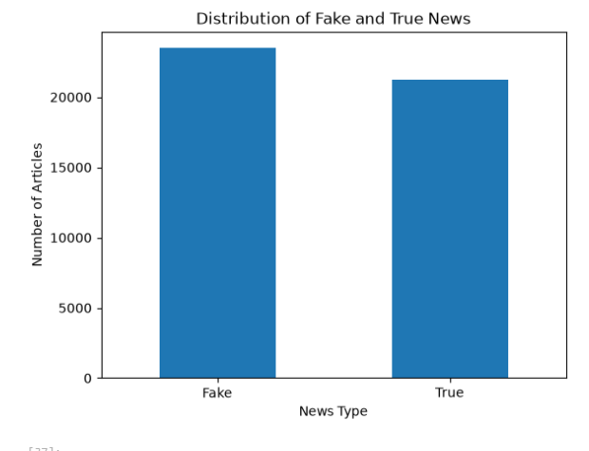

2.4 News Subject Distribution
The major subject categories in the cleaned dataset were:
Subject | Number of Articles
politicsNews | 11,215
worldnews | 9,980
News | 9,050
politics | 6,424
US_News | 783
left-news | 683
Government News | 515
The dataset was therefore concentrated around political, world, and general news categories.
Figure 2: Distribution of News Subjects
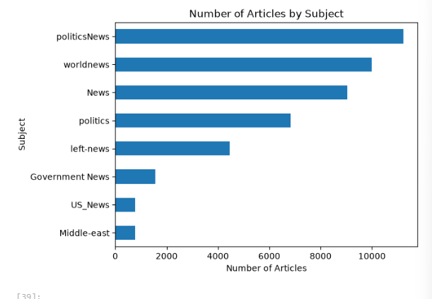
An important observation was that certain subject categories were strongly associated with the Fake/True labels. For example, some subjects appeared exclusively within one class.
This means that the subject variable may contain information about how the dataset was constructed rather than information about whether an article is genuinely fake or true.
Consequently, if a machine-learning model were developed in the future, subject would need to be treated carefully because it could introduce data leakage and produce misleadingly high predictive performance.

2.5 Distribution of Articles by Year
The cleaned dataset contained articles from 2015 to 2018.
Year | Number of Articles
2015 | 1,598
2016 | 13,915
2017 | 23,102
2018 | 35
Most records were from 2016 and 2017, with 2017 containing the largest number of articles.
Figure 3: Number of Articles by Year
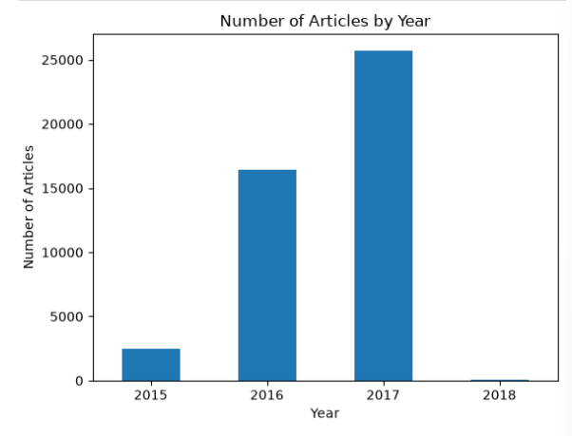
This distribution represents the records available in the dataset and should not be interpreted as the total amount of news published globally during these years.

2.6 Text Length Analysis
Article text length was calculated to examine whether Fake and True articles differed in their amount of text.
The average text lengths were approximately:
Label | Average Text Length
Fake | 2,619 characters
True | 2,378 characters
Fake articles therefore had a somewhat higher average text length.
However, the median text lengths were much closer. This indicates that the difference in average length is influenced partly by longer articles and should not be interpreted as a strong distinguishing characteristic by itself.
The dataset also contained some extremely long articles, with the maximum text length exceeding 50,000 characters.
Figure 4: Average Text Length by News Label
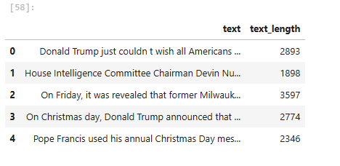

2.7 Key Findings from the Fake News Analysis
The main findings from this analysis were:
- The final cleaned dataset contained 38,650 articles.
- True articles represented 54.84% of the dataset, while Fake articles represented 45.16%.
- The majority of records came from 2016 and 2017.
- Political and general news subjects represented a large portion of the dataset.
- Fake articles had a somewhat higher average text length than True articles.
- The subject variable showed a very strong association with the Fake/True label.
- This strong subject-label relationship may represent a dataset construction issue or potential information leakage.

3. Analysis 2: Customer Transactions
3.1 Dataset Description
The second analysis used two datasets:
- Customer dataset
- Transaction dataset
The customer dataset contained:
5,000 customer records and 17 variables
The transaction dataset contained:
219,843 transaction records and 8 variables
The customer dataset included information such as:
- Customer ID
- Account ID
- Working balance
- Account opening date
- Account status
- Customer type
- Region
- Sector
- Card status
- Banking service indicators
The transaction dataset included:
- Customer ID
- Account ID
- Transaction amount
- Transaction ID
- Transaction timestamp
- Debit/credit indicator
- Narrative
- Transaction description

4. Customer Data Cleaning and Preprocessing
4.1 Missing Values
Missing values were identified in several categorical and text columns.
In the customer dataset, missing values were found in:
- Restriction Code
- Address
- Email
- Product Group Description
- Card Status
Instead of removing these records, missing categorical/text values were replaced with "Unknown".
This allowed the records to be retained for further analysis.
The transaction dataset contained missing values in:
- Transaction ID
- Narrative
- Transaction Description
These were also replaced with "Unknown".
After this process, the datasets contained no missing values in the fields being analysed.

4.2 Date Preprocessing
The following columns were converted to datetime format:
- Customer opening date
- Maximum transaction date
- Transaction timestamp
This allowed dates to be used for time-based analysis, including yearly and monthly transaction analysis.

4.3 Duplicate Records
The datasets were checked for exact duplicate rows.
The results showed:
- 0 duplicate customer rows
- 0 duplicate transaction rows
Therefore, no records needed to be removed because of exact duplication.

5. Customer Characteristics
5.1 Account Status
The customer dataset contained three account-status categories:
Account Status | Number | Percentage
Dormant | 3,260 | 65.20%
Active | 1,456 | 29.12%
Inactive | 284 | 5.68%
Total | 5,000 | 100%
The largest group was Dormant customers, representing 65.2% of the dataset.
Figure 5: Customer Account Status
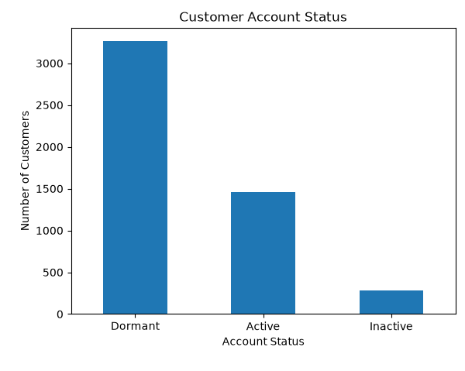

5.2 Customer Type
The customer dataset was predominantly made up of Individual Customers.
The largest groups included:
- Individual Customer – 4,106
- Corporate Customer – 332
- Salary Customer – 183
- Minor – 147
- Enterprise Customer – 100
- MSME – 39
Individual Customers represented approximately 82.12% of all customer records.
This indicates that the customer population in this dataset is primarily composed of individual customers.

5.3 Customer Sector
The customer dataset was heavily concentrated in the GENERAL sector.
The main sector counts included:
- GENERAL – 4,046
- ADMIN AND SUPPORT SERVICE ACT. – 348
- GENERAL COMMERCE – 180
- OIL AND GAS – 103
- TRANSPORTATION AND STORAGE – 49
- AGRICULTURE – 47
The remaining sectors contained relatively small numbers of customers.
This concentration means that comparisons between sectors should be interpreted carefully.

5.4 Customer Region
All 5,000 customers belonged to:
APAPA & BEYOND
Because only one region was represented, regional comparisons could not be performed.
This is an important limitation of the dataset.

6. Transaction Analysis
6.1 Transaction Amount Distribution
The AMOUNT_LCY variable was analysed using descriptive statistics.
The results were:
Statistic | Amount
Mean | 307,575.50
Median | 7,282.10
Minimum | 0.01
Maximum | 2,018,167,000
The mean was considerably higher than the median.
This indicates that the transaction amounts were highly right-skewed, with a relatively small number of very large transactions influencing the average.
For this reason, the median is a useful measure when describing the typical transaction.

6.2 Debit and Credit Transactions
The transaction dataset contained:
Transaction Type | Number | Percentage
Debit | 156,537 | 71.2%
Credit | 63,306 | 28.8%
Total | 219,843 | 100%
Debit transactions were therefore much more frequent than credit transactions.
Figure 6: Transaction Count by Debit and Credit
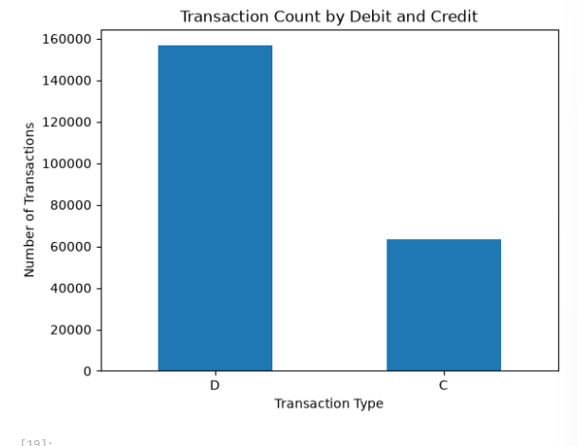
However, the total amounts were relatively close:
- Credit transactions: approximately 32.97 billion
- Debit transactions: approximately 34.64 billion
The median credit transaction was also higher than the median debit transaction.
This shows that transaction frequency and transaction value provide different perspectives on activity.

7. Transaction Timing
7.1 Yearly Distribution
All transaction records occurred during 2020.
Therefore, the yearly analysis produced one year of transaction activity.
7.2 Monthly Distribution
The transaction records were distributed as follows:
Month | Number of Transactions
August | 2,328
September | 217,499
October | 16
Total | 219,843
Approximately 98.9% of all transactions occurred in September.
Figure 7: Transaction Count by Month in 2020
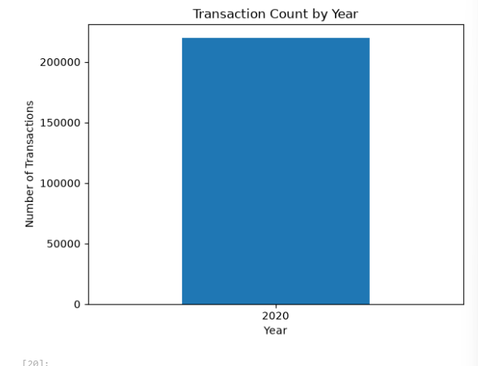
The strong concentration in September is an important characteristic of the dataset. It also means that the data does not provide a balanced view of transaction activity throughout the entire year.

8. Customer and Transaction Data Integration
An attempt was made to connect customer information with transaction information using accountid.
The customer dataset contained:
- 5,000 customer records
- 4,995 unique account IDs
The transaction dataset contained 219,843 transaction records.
Only:
21,379 transaction records
matched customer account IDs.
These matched transactions represented:
868 unique accounts
This means that only approximately 9.7% of all transaction records could be linked to the customer dataset.
The unmatched transactions were not removed because doing so would discard approximately 90% of the transaction dataset.
Instead, the full transaction dataset was retained for general transaction analysis, while the matched subset was used for customer-level analysis.
This limited overlap was treated as an important data integration and data quality finding.

9. Account-Level Transaction Analysis
For the 868 matched accounts, transaction-level information was aggregated to calculate:
- Number of transactions
- Total transaction amount
- Average transaction amount
- Median transaction amount
This allowed transaction activity to be examined at the individual account level.

9.1 Most Active Accounts
The account with the highest number of transactions had:
- 524 transactions
- approximately 15.0 million in total transaction value
Other highly active accounts also had substantial transaction values.
However, transaction frequency did not necessarily correspond to total transaction value.

9.2 Highest-Value Accounts
The account with the highest total transaction value had:
- 3 transactions
- approximately 424.2 million in total transaction value
Another account had:
- 152 transactions
- approximately 329.2 million in total transaction value
This demonstrates that an account can have relatively few transactions while still processing a very large total value.
Therefore, both transaction frequency and transaction value should be considered when assessing account activity.

10. Transaction Activity by Customer Type
The 868 matched accounts were grouped according to customer type.
Customer Type | Accounts | Transactions | Total Transaction Value
Individual Customer | 662 | 17,606 | 1.31 billion
Salary Customer | 91 | 1,523 | 29.52 million
Corporate Customer | 51 | 917 | 1.60 billion
Individual Staff | 12 | 352 | 12.62 million
Enterprise Customer | 16 | 345 | 63.84 million
MSME | 11 | 228 | 312.55 million
Minor | 15 | 190 | 15.16 million
Other customer categories had very small numbers of matched accounts.
Figure 8: Total Transaction Value by Customer Type
[Insert your 8-bar customer-type graph here]
The results show that the number of accounts does not necessarily correspond to total transaction value.
For example, Individual Customers represented the largest number of matched accounts and had the highest number of transactions, while Corporate Customers had fewer accounts but a higher combined transaction value.
Groups with only one or two matched accounts should not be used to make broad conclusions because their sample sizes are too small.

11. Transaction Activity by Account Status
The 868 matched accounts were also grouped according to account status.
Account Status | Accounts | Transactions | Total Transaction Value
Active | 742 | 20,183 | 3.12 billion
Dormant | 67 | 557 | 102.41 million
Inactive | 59 | 639 | 206.90 million
Figure 9: Total Transactions by Account Status
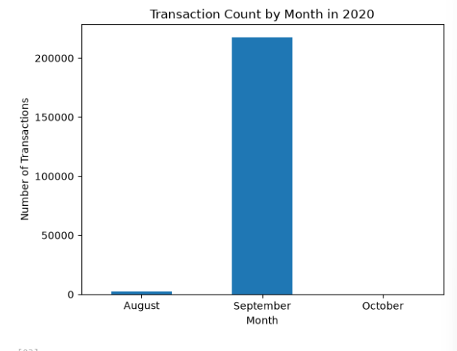
Active accounts represented the majority of the matched accounts and accounted for most of the observed transactions.
These results apply specifically to the 868 matched accounts and should not be generalized to all 5,000 customers.

12. Transaction Activity by Sector
The matched accounts were also grouped by sector.
The main results were:
Sector | Accounts | Transactions | Total Transaction Value
GENERAL | 746 | 18,737 | 1.414 billion
CONSTRUCTION | 5 | 174 | 740.45 million
OIL AND GAS | 13 | 375 | 651.65 million
GENERAL COMMERCE | 32 | 801 | 392.92 million
TRANSPORTATION AND STORAGE | 9 | 308 | 76.13 million
ADMIN AND SUPPORT SERVICE ACT. | 37 | 702 | 26.76 million
The GENERAL sector had the largest number of matched accounts and transactions.
However, some sectors with relatively few accounts had substantial total transaction values.
For example, Construction had only five matched accounts but approximately 740.45 million in transaction value.
This again demonstrates that the number of accounts and the value of transactions measure different aspects of financial activity.

13. Final Data Quality Check
A final quality check was performed on the merged transaction dataset.
The results were:
- 21,379 merged rows
- 0 duplicate rows
- 0 missing account IDs
- 0 missing customer types
- 0 missing account statuses
- 0 missing sectors
- 0 missing product group descriptions
This confirmed that the final merged dataset used for customer-level transaction analysis was internally consistent with respect to the selected fields.

14. Overall Key Findings
The main findings from the entire project were:
Fake News Analysis
- The final cleaned dataset contained 38,650 articles.
- True articles represented 54.84% and Fake articles represented 45.16%.
- Most records came from 2016 and 2017.
- Political and general news categories made up a large proportion of the dataset.
- Fake articles had a somewhat higher average text length than True articles.
- The strong relationship between subject and label suggests a possible dataset construction issue or information leakage.
Customer Analysis
- The customer dataset contained 5,000 customers.
- 65.2% of customers were classified as Dormant.
- 82.12% were Individual Customers.
- All customers belonged to the same region.
- The GENERAL sector represented the majority of customers.
Transaction Analysis
- The transaction dataset contained 219,843 transactions.
- Debit transactions represented 71.2% of all transactions.
- Transaction amounts were highly right-skewed.
- The median transaction amount was much lower than the mean.
- Approximately 98.9% of transactions occurred in September 2020.
- A small number of very large transactions had a substantial effect on total transaction values.
Customer–Transaction Integration
- Only 21,379 transactions, or approximately 9.7%, matched customer account IDs.
- These transactions represented 868 unique accounts.
- Transaction frequency and transaction value were not necessarily related.
- Some customer groups and sectors with relatively few accounts generated substantial transaction values.

15. Limitations
Several limitations should be considered when interpreting the results.
Fake News Dataset
The Fake News dataset has an uneven distribution across years and only covers records up to February 2018. The strong association between subject and label may also reflect the way the dataset was constructed.
Therefore, the findings should not automatically be generalized to all news articles or current news.
Customer Transactions Dataset
The customer and transaction datasets had limited overlap, with only approximately 9.7% of transaction records matching customer accounts.
The customer dataset also contained only one region, meaning regional comparisons were not possible.
Transaction records were highly concentrated in September 2020, which limits analysis of seasonal or yearly trends.
Finally, transaction amounts were strongly skewed, meaning averages can be heavily influenced by a small number of very large transactions.

16. Conclusion
This project demonstrated the complete process of preparing and exploring real-world datasets using Python.
The analysis began with data inspection and cleaning, followed by preprocessing, duplicate checks, missing-value treatment, date conversion, aggregation, data integration, and visualization.
The Fake News analysis produced a cleaned dataset of 38,650 articles and identified patterns in news labels, subjects, publication years, and article lengths.
The Customer Transactions analysis identified patterns in customer characteristics, transaction types, transaction amounts, transaction timing, account activity, customer types, account statuses, and sectors.
One of the most important findings was the limited overlap between the customer and transaction datasets. Rather than removing the majority of transaction records, the analysis preserved the full transaction dataset and used the matched subset for combined customer-transaction analysis.
Overall, the project demonstrates how exploratory data analysis can be used to identify patterns, detect data-quality issues, understand dataset limitations, and generate meaningful insights before further statistical or machine-learning analysis is attempted.
The analysis also highlights an important principle of data science: understanding the structure and limitations of the data is just as important as producing results from it.

